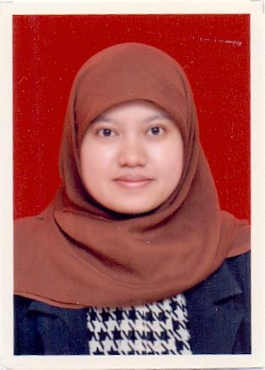  About Me:  Name : Nita Rustanti  Date of birth : 26 may 1989  Place of birth : Bandung  Gender : Female  Expertise : Japanese Lecture  Nationality : Indonesia  Adrress: Margacinta 1 no 1, Bandung 40287  Email: rustanti.nita@gmail.com  Phone: 085659221274 | Experience  2013 – 2014  Ass Manager , Jonas Photo  Helps a manager by taking on some managerial tasks, such as making a report, administration, etc  2013 – now  Japanese Lecture, politeknik piksi ganesha  Teaching basic Japanese  Education  2007 2011  S.S, UNPAD  GPA = 3.70  Yudicium = cum laude  2013 2016  M.Pd, UPI  GPA = 3,77  Scholarship from BPPDN DIKTI and Japan Foundation  Skills  - English Skill (Writen) - Japanese skill (Written) - good analytical  Activities  Teaching basic Japanese and translating some part of Japanese magazine as my hobby. Also has published some articles in national journal.

